Rahaf Muteb-2005876

GitHub :

https://github.com/RahafMuteb/resume.git

cv.html

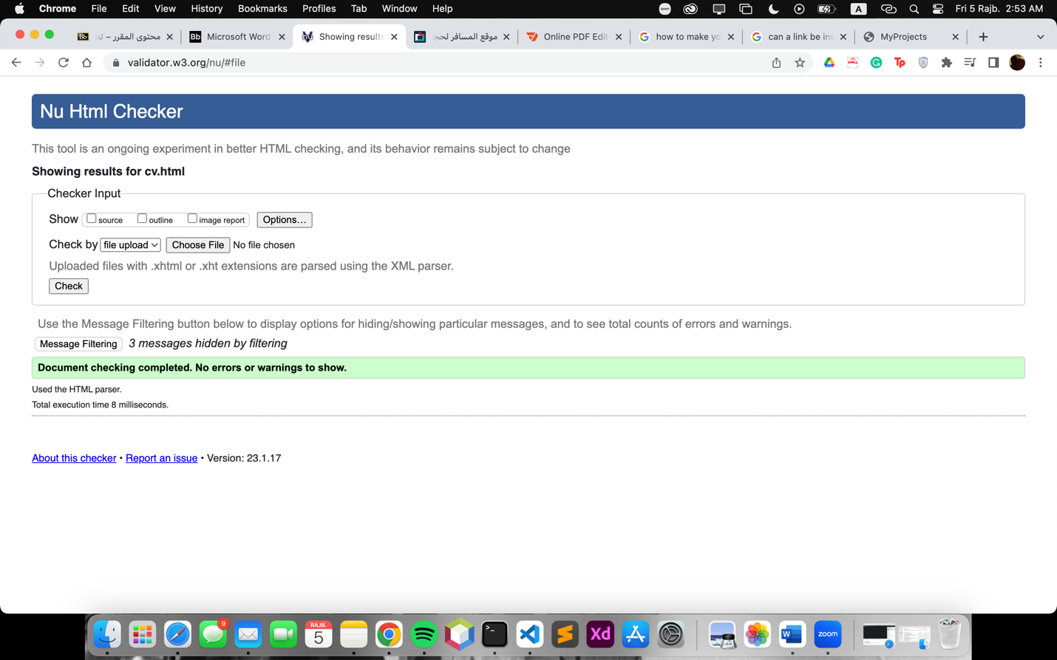

Project.html

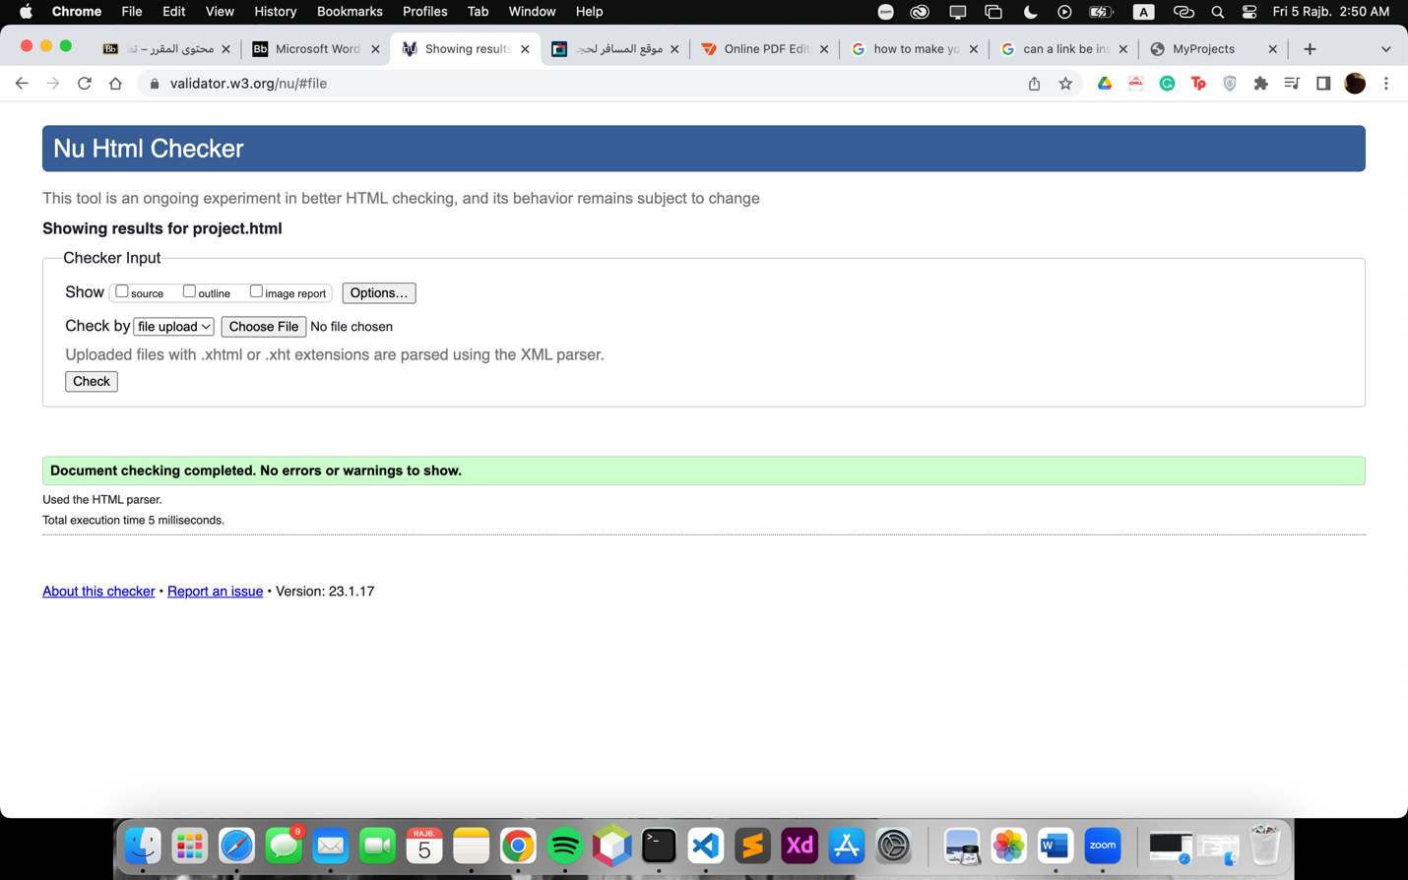

contactMe.html

